Warm Up

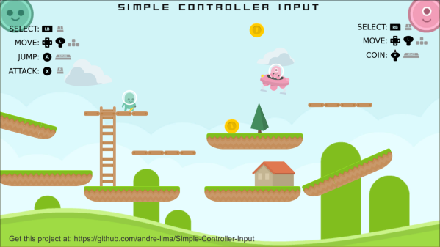

How do you think the game's behaviors and logic are implemented?

|  |
| --- |